Summary Learning hari senin 10 Mei 2021

1. Git Version Control Sistem di belajar koding
   1. 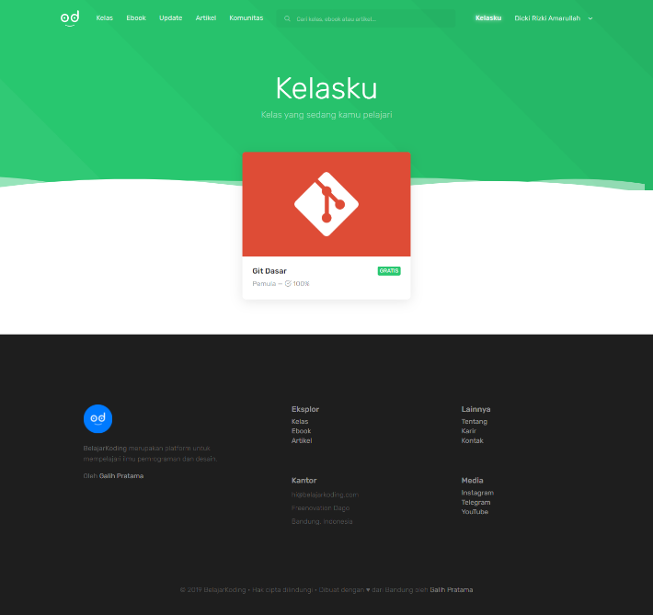
   2. Belajar instalasi redhat dan command nya, baru selesai baca baca untuk dual booting windows dan redhat 8, sudah berhasil download iso, yang belum installnya.

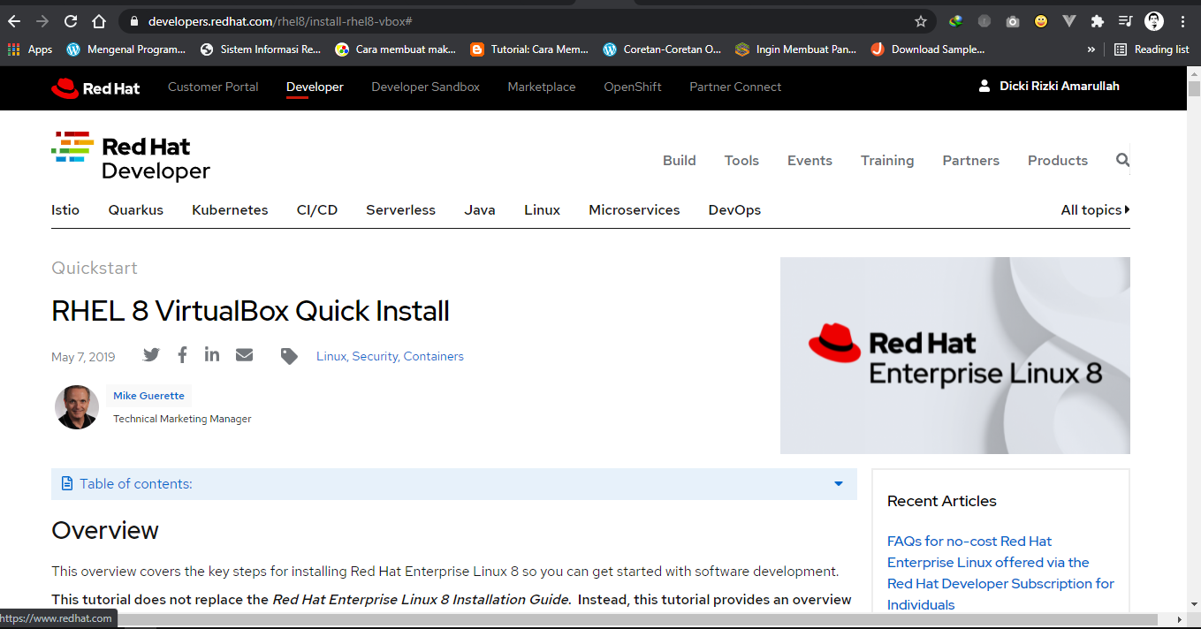

Ref:

1. <https://developers.redhat.com/rhel8/install-rhel8-vbox#>
2. <https://dwinar.web.id/2018/07/27/cara-install-redhat-7/>
3. <https://www.cyberciti.biz/faq/linux-unix-appleosx-bsd-cat-command-examples/#1>
4. <https://blog.turbonomic.com/blog/on-technology/deploying-a-red-hat-enterprise-linux-7-rhel7-on-virtualbox>